|  |
| --- |
| **bluesky studios** |
| **Trick or Treat** |
| A Platform Game |
| Version #01  All work Copyright © 2016 by BlueSky Game Studios.  All rights reserved. |
| **Angela Liu** |
|  |



|  |
| --- |
| October 14th 2016 |

**Table of Contents**

Contents

Game Overview 4

Game Play Mechanics 4

Camera 4

Controls 4

Interface Sketch 5

Menu and Screen Descriptions 6

Characters 9

Enemies 9

Items 9

Scoring 9

Sound Index 9

Story Index 9

Art / Multimedia Index 10

**Version History**

Github link <https://github.com/COMP305-F2016/Assignment-2-TrickorTreat>

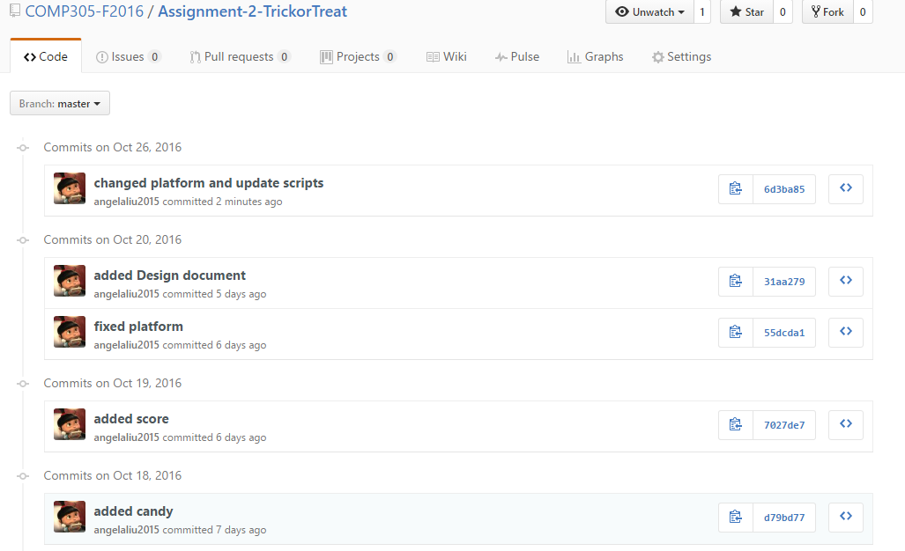

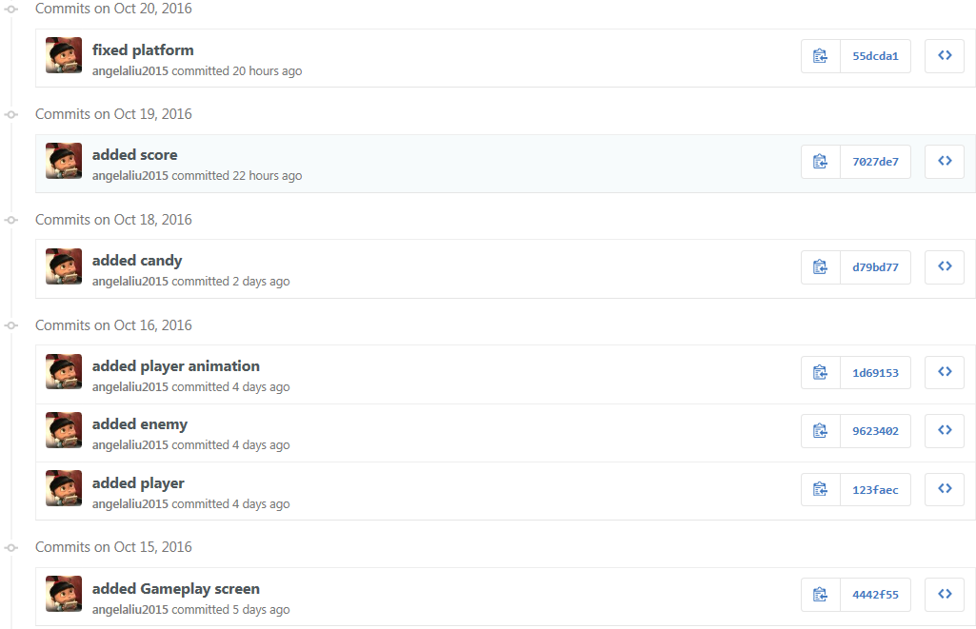

# Game Overview

*Trick Or Treat is a simple platform game. The player’s avatar is Jack O Lantern who is limited to walk on the platform in the graveyard and can run side to side or jump up and down. The multiple platforms are shown grass form, long form and grave form. The player’s goal is to avoid the ghosts and collect candies in the graveyard at Halloween night.*

# Game Play Mechanics

*The player can use key as input.*

# Camera

*The camera for this game uses an orthographic project from a top-down (birds-eye) view to follow the player.*

# Controls

*The game uses that key as the primary control mechanism.*

*The control for this game is with the key. The arrow key or ADWS allows the player to move left to right across the screen. The player can jump by using space.*

# Interface Sketch

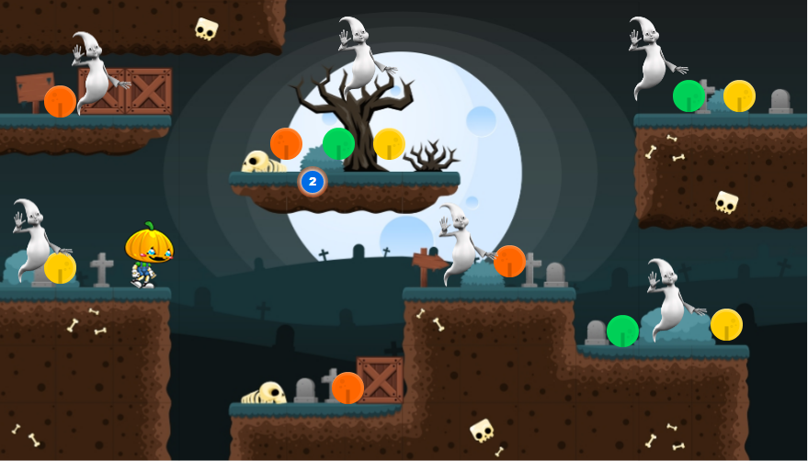

# Menu and Screen Descriptions

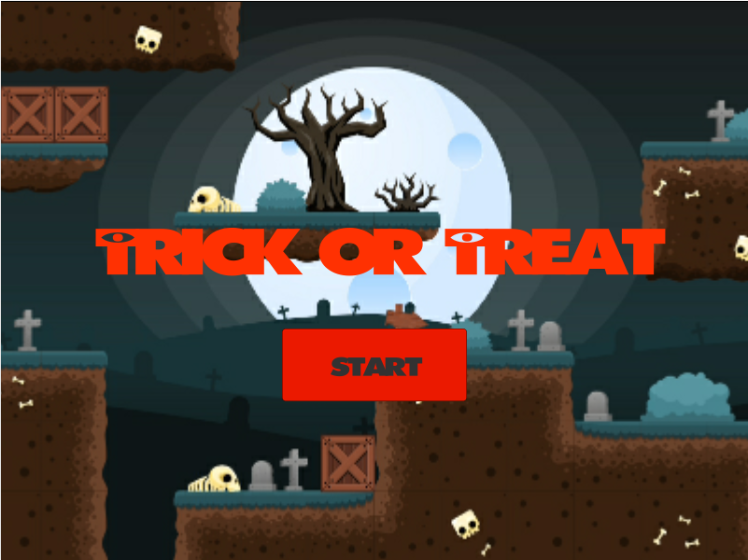

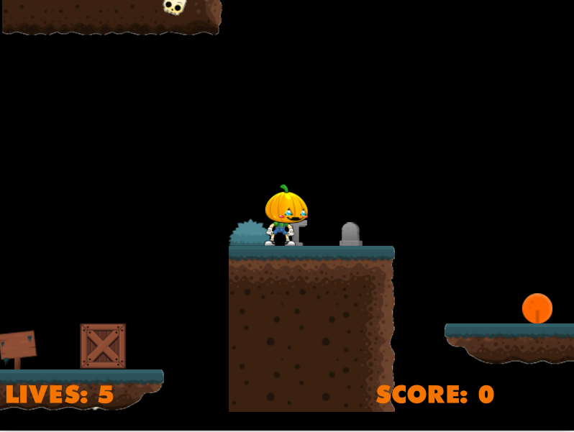

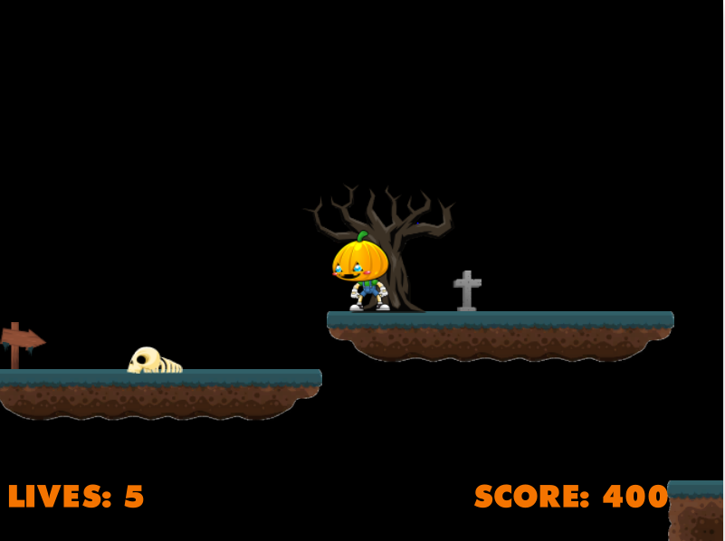

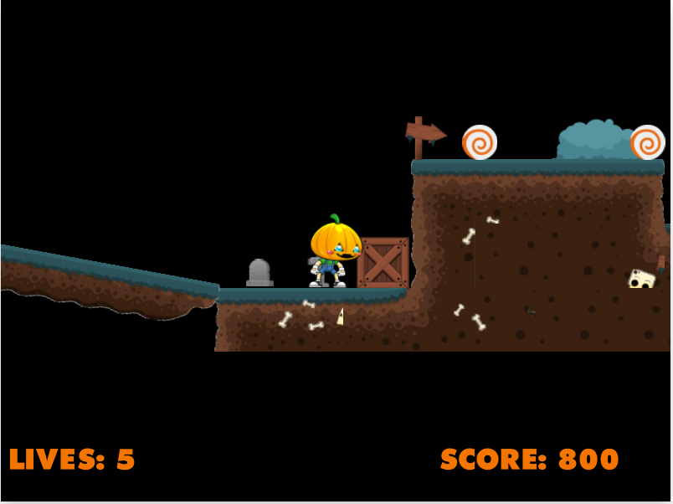

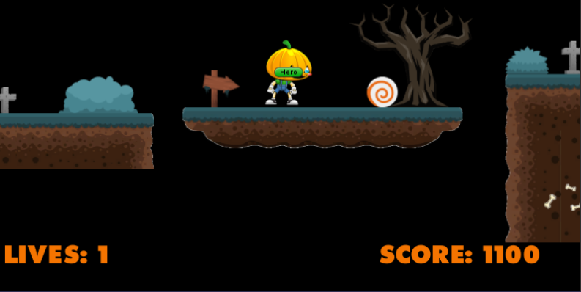

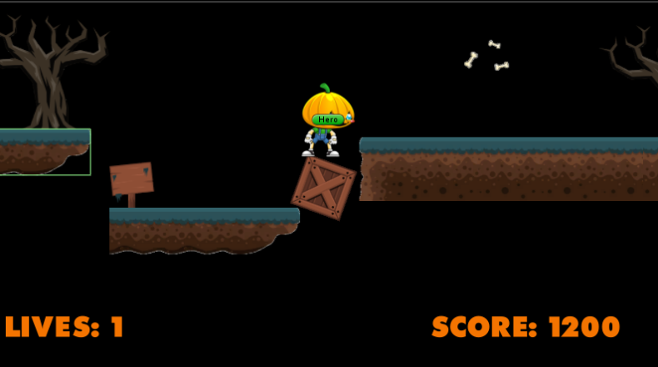

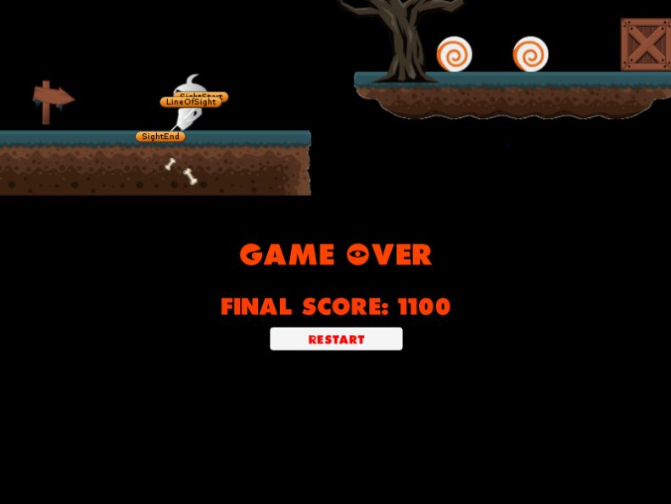

# Characters

*The player’s avatar is a simple Jack O Lantern that seems to run/walk/idle/jump over the platform. The player movement can be run and jumped from left to right or bottom to top. When Jack O Lantern jumps on the ghost’s head, the ghost will be destroyed. Otherwire, the live of Jack O Lantern will be decreased. When Jack O Lantern collects the candies, the scores will be increased. When the score reaches 2000, the player can go to next level.*

# Enemies

*The enemies in the game are the ghosts. Let’s image them as hitting at the player.*

# Items

*The player collects the candies. The scores will be increased.*

# Scoring

*Scoring in the game is accomplished by collecting candies. Each time the player’s Jack O Lantern collects a candy awards the player 100 scores. The player starts with 5 lives. Each time the player collides with a ghost could he lose a lift.*

# Sound Index

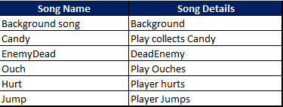

# Story Index

*The story is about Jack O Lantern trick or treat in the graveyard on the Halloween night. He wants to collect the candies as much as he can. Meanwhile there are many ghosts encountered in the graveyard. Jack O Lantern needs to avoid or destroy them.*

# Art / Multimedia Index

